Training of TLS Online Ordering

- Introduction to TLS Online Ordering w/Zuppler
- Menu’s & CP Configuration / Settings
- Restaurant Menu’s and how to use them

Chapter 1- Introduction to TLS Online Ordering w/Zuppler

Anytime that you’ll go and make a change to a client’s menu or to check out a client’s online ordering menu you’ll want to head over to the following URL: restaurants.zuppler.com
The login is clipper@zuppler.com
The password is zuppleruser

Once logged in you will see the following screen:
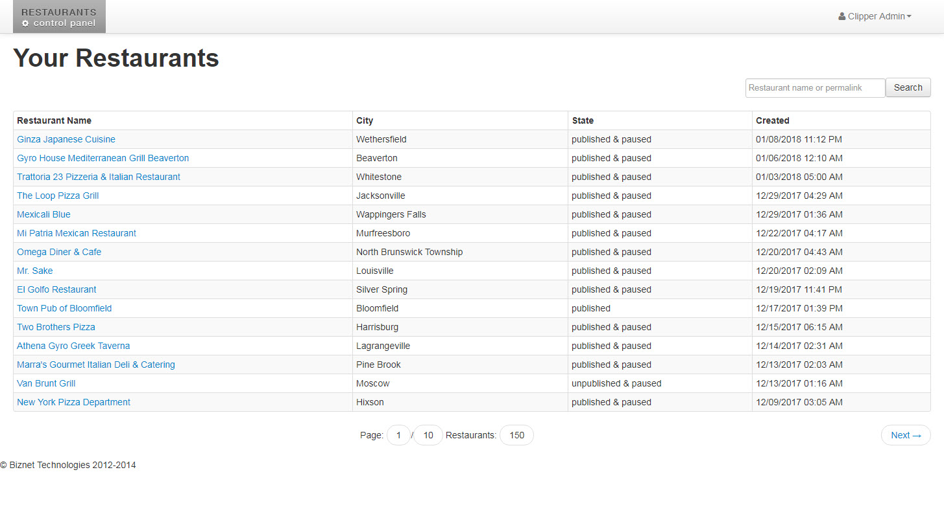
This screen will show you all of current TLS Online Ordering clients, the city that they’re in, the current status and when it was created.
The three statuses you’ll see most of the time are Published, Unpublished, and Published & Paused
Published means that they are currently live with us. Unpublished means that Zuppler has not completed their work on it, and published & paused means Zuppler has completed their work on the menu but they are currently not live.

You are able to search for the client you’re looking for by typing in their name in the upper right hand corner.

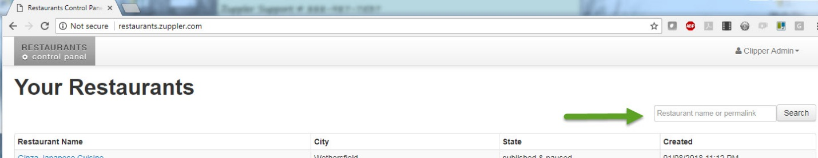

Once you find the client you’re looking for and click on it, you will be taken to their profile page.
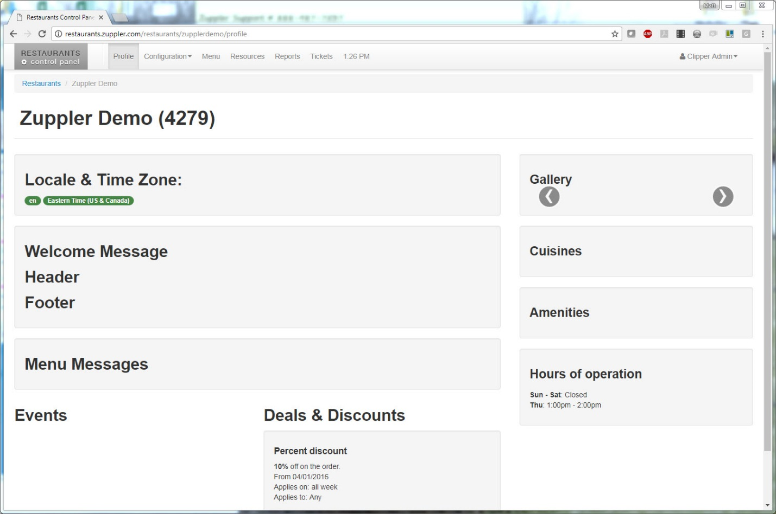
Here you’ll find the name of the business, the Zuppler ID # they assign to it, their gallery, the cuisines, their amenities, hours of operation etc.
Most of this information you won’t really do anything with, including locale & time zone, welcome message, header, footer, menu messages, events, cuisines, and amenities.

Deals & Discounts & Inactive Discounts
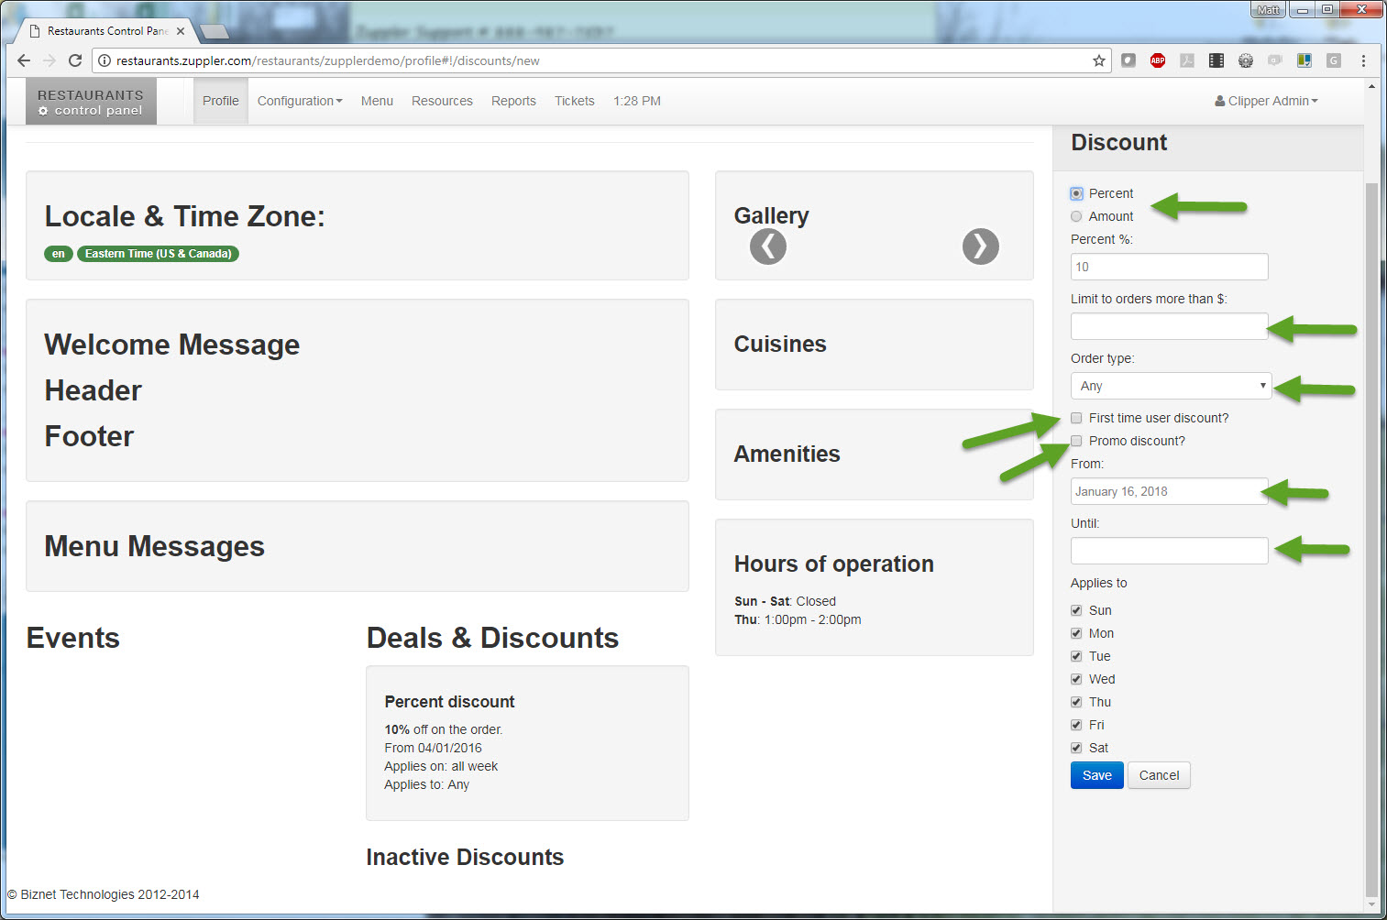
Here is where you’ll be able to add a discount (either percent off or amount off) the max amount (ie. $5 off $25 or more) the order type, be it pickup & Delivery orders, just delivery, just pickup, eat in, etc.
You can also decide if you’d like this to be a first time user discount or a promo discount. If it’s a first time user discount, it means that only people that create an account will be able to receive this discount.
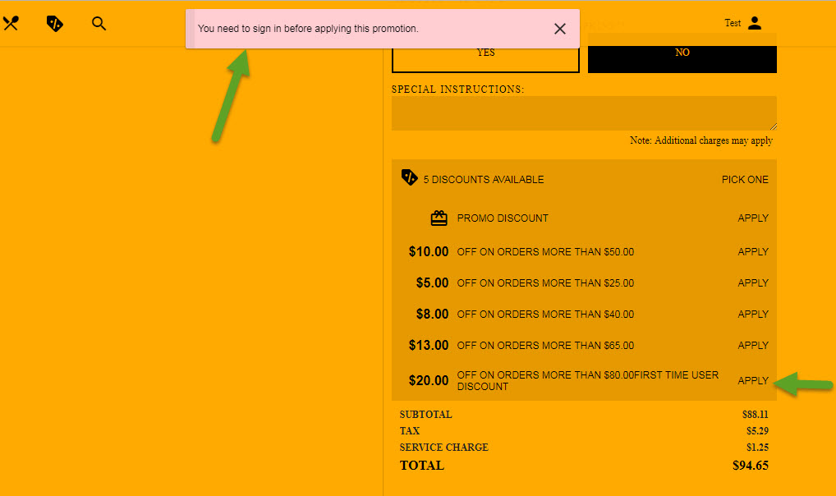
You can also choose not to select first time user or promo code. This would mean that the discount is always available to anyone and they can use it multiple times.

Chapter 2- Menu’s & CP Configuration / Settings
At the top of the CP you will see Profile, Configuration, Menu, Resources, Reports and Tickets
Profile will take you back to the main page where you’ll see discounts, welcome message, header, footer etc.
Configuration- There are actually 5 sub menus that make up the Configuration, those being Overview, Services, Settings, Notifications, and Tenders.
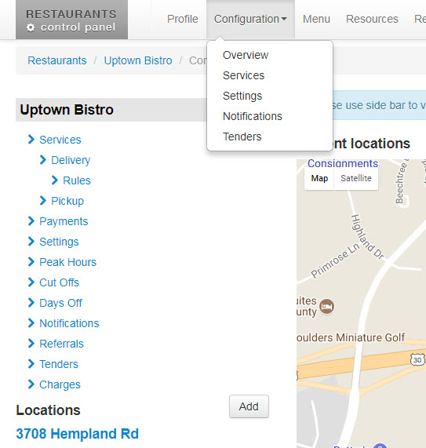

All 5 of these will take you to the same list of information with that list being the following:
Services- This will show what services they provide, Delivery, pickup, etc.
Delivery (will only be visible if restaurant offers delivery service) - This will show the restaurant contact for deliveries. It will also show the min order for delivery, when delivery is available, how long it will take for a delivery, and when delivery is available.
Rules (will only be visible if restaurant offers delivery service)- This shows the delivery rules that have been set up for the restaurant. The rule could be one of the following: Zip Code, Circle, and Rectangle.
Pickup- Gives you the contact person for pickups at the restaurant and also the settings, min order amount, start time and cutoff time. Almost 100% of the time you will not find any information in the pickup settings.
Payments- This will show what types of tenders that the restaurant accept, Credit Card or Cash or both.
Settings- You’ll find most of the accounts settings in this section.
- Default Order Type- Will show as the default type when the customer checks out
- Default payment type- Again this will show all of the types of payment they accept
- Kitchen close- this is the time, in min, that the kitchen closes before the closing time
- Sales Tax- The amount of sales tax that the customer charges
- Tax post discount and taxable delivery charge- You will not have to worry about these two as we don’t do anything with this.
- Service charge- This is the amount that the restaurant would like to change their customers for online ordering ie. $1.50, $1.25 etc.
- Loyalty- again don’t have to worry about this as we don’t do anything with it.
- Top picks- Having this checked mark will show returning customers the top picks in online ordering.
- Allow Tip- Self explains itself, it allows people to add a tip to their online order.
- Order Time takes- Again you can ignore this as we don’t do anything with this.
- Allow ASAP- If this is checked it means that the restaurant will allow customer to place ASAP orders, which means customer want their order as soon as possible. Which is usually based on the restaurants prep time they have set.
- Disable Future Orders- If this is checked it means that the restaurant will not allow customers to place orders for the future be it 2 hours from now or 2 days from now.
- Scheduled Order Time- This is another item you can ignore as we don’t do anything with this.
- Disable Group Ordering- This is another item you can ignore for the time. This is a new feature that’s being worked on.
- Disable Quantity- This is another item you can ignore as we don’t do anything with this.
- Default Prep Time- This is the default time that the restaurant needs to create an order.
- Require Cross Street- Again you can ignore this setting as we don’t do anything with it.
- Plastic Silverware- If this is checked, it asks customers if they need plastic silverware & napkins. If a customer does not want to offer it, just uncheck this box.
- Hide Special Instructions – If this is checked it does not allow customers to submit special instructions such as place put sauce on side.
- Display SOLD OUT- You can ignore this item as we do not do anything with it.
- Enable Modifier images- If this is checked it will allow us to add images to items that are a modifier (we’ll get to this). At this time I do not believe we’re letting customers do this.
- Only Catering Menu
- Fax copies down to Increase visibility can all be ignored as this is set up for us by Zupper.
Peak Hours – As right now you do not need to worry about this. This is a feature that’s active but we’re still playing around with it to make sure it works correctly before we start using it.
Cut Offs- again you can ignore this as it’s something that we do not use.
Days Off- This section is where you would put in the days off that the client is not open. For example, Christmas Eve, Christmas Day etc., you could put in those dates in this section. **Please note that every year on Jan 1 we will have to go back into this section for each of our clients and add those days off again.
Notifications- This section will show the type of notification (how they receive their orders) that they’re using. In this section you will also be able to see a notification type if requested (ie. Fax, email)
Referrals- You don’t have to worry about this section as we don’t do anything with it.
Tenders- Shows what forms of tender they accept for their orders.
Charges- This is the same section where you would add the service charge.

Menu- This will take you to a copy of the clients menu that’s been put into the system.
Resources- Here is where you will add the restaurant’s logo and images to use for their online menu.
Reports- This is another way to access your clients reports.
Tickets- This is where you could go if you need to pause your clients online ordering.

Chapter 3- Restaurant Menu’s and how to use them
Once the menu has been completed by Zuppler and internal proof reading is completed we’ll send the menu preview to the client.
To see a client’s menu, you’ll again go to restaurants.zuppler.com and you’ll search for your client. We’ll use our demo Uptown – Bistro for this.
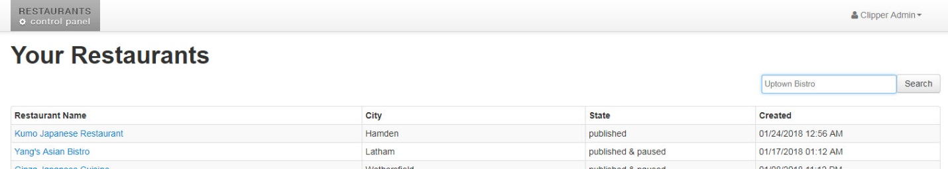

You’ll again see the profile page. From there you’ll want to click on the menu button at the top.
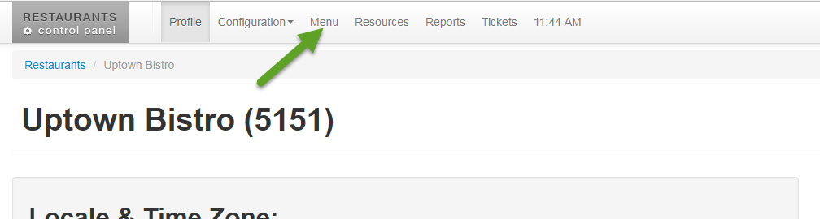

Once you click on menu you’ll be taken to the menu that’s been created for them. For Uptown you’ll see that we have a Breakfast Menu a Lunch menu & their overall menu.
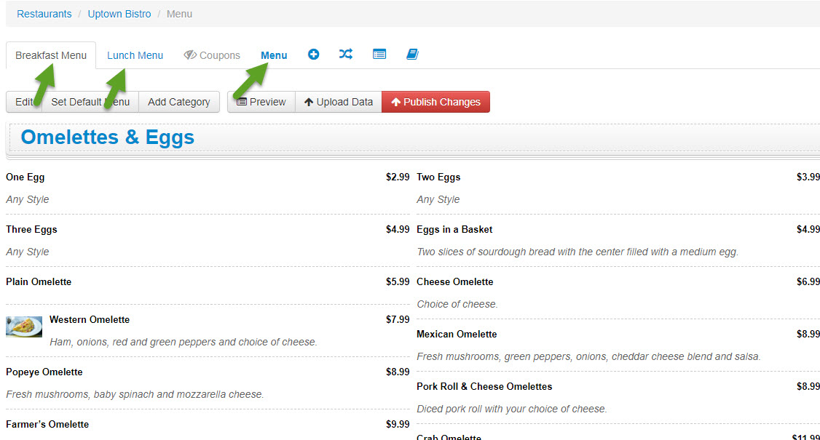
So let’s take a look at their main Menu.
You’ll see all of the categories that are in the menu: Appetizers, Salads, Burgers, etc.
You’ll also see which menu items are in each category. For example in the appetizers category you’ll see wings, mozz sticks, fried dill pickles, etc.

How to make changes to a menu item
So your client might call and say hey, we need to change the price of our garlic fries. Can you take care of this for us?
This is pretty simple. You’ll first want to click on the individual item you’d like to make the change to, in this case Garlic Fries. Once you click on Garlic Fries it will take you to the information for that item:
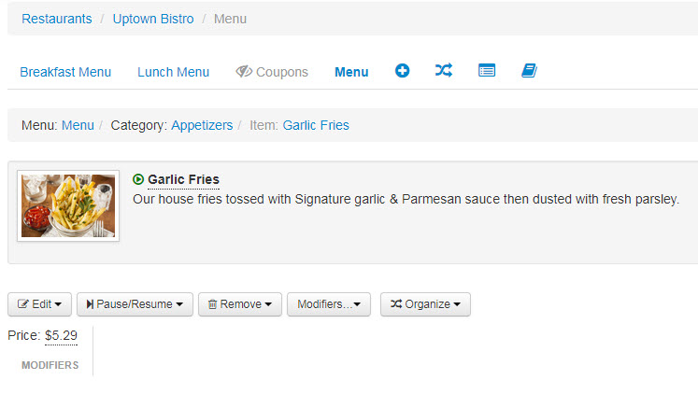
You’ll see what menu the item is located in, the category that the item is in and the item name. For this example you’ll see the Menu it’s in is Menu, the Category is Appetizers and the item Garlic Fries.

So the client tells you, change the price from $5.29 to $4.29. This is a very simple change. You’ll first click on the edit button:
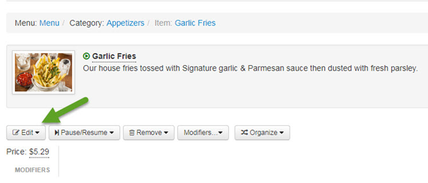
Once you click on Edit, you’ll see a dropdown box appear with the choice of Edit Garlic Fries and Edit Garlic Fries Details.
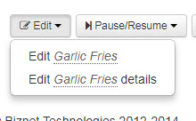
You’ll want to click on Edit Garlic Fries details, which will bring up the following screen on the right side of the page: 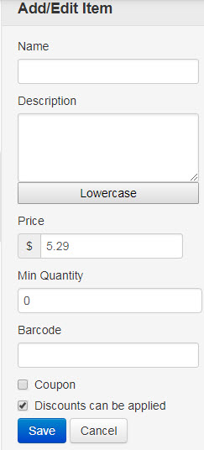
You’ll see the price listed is $5.29. All you’ll have to do is go to the price field and change the price from 5.29 to 4.29 and click the save button.
You’ll now see that the price has now changed to $4.29 instead of $5.29:
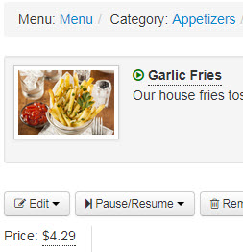
So what about something a little more complexed that have multiple choices known ad Modifiers?
Let’s take a look at Build Your Own Pizza, under the Pizza Category.
You’ll see when we click on it we have different sizes of pizzas to choose from, and different modifiers, such as pizza sauce, whole toppings, right half toppings left half toppings.
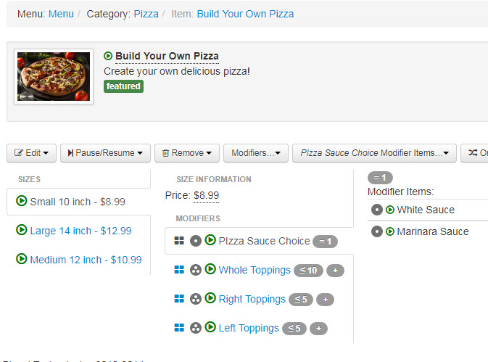
I’m going to switch over to our Demo menu at this point as our Uptown Bistro is a LIVE working example for our sales team to use.

So you’ll see on our demo menu I’ve created a Pizza Category and a Build Your Own Pizza item with the sizes Small, Medium, Large, X-Large.
Let’s Start with Modifiers on the small pizza.
You’ll want to make sure that you have size small selected:
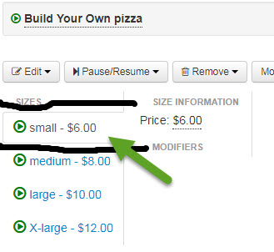
You’ll be able to tell which one you have selected by the small box that’s around the item you’ve selected.
Once you’ve clicked on small you’ll see that there are no modifiers that have been created for this size.
The simple way to explain what a modifier is is to say that it’s a choice that you’re giving the customer.
So let’s make a modifier. I’m going to call this first one Type of Sauce. So you’ll want to click on the word Modifiers:
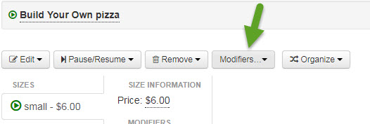
Once you click on it you’ll see the following dropdown box:
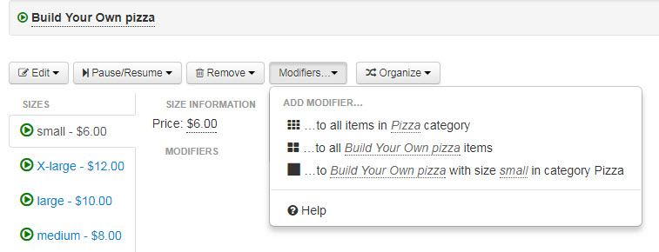
You’ll see the options you have. You can add a modifier to all items in Pizza category, to all Build Your Own Pizza items or to Build Your Own pizza with size small in category Pizza.
You all see the icons that go with those choices as well. The simple way to know which one to select, the icon with 6 small boxes means that the modifier you create here will also be created on all items in the Pizza category. The icon with 4 boxes means that the modifier you create here will be also be created on all build your own pizza items. The final icon is the safest one to use if you’re not sure which one you want to do. This icon is a large box which means it will be add to this item and this item only.
So, an easy quiz. You want to create a modifier (AKA Choice) for Type of Sauce, giving your customers a choice on the type of sauce they want.
Which modifier would you choose?
Before you answer you would need to know if the Type of Sauce is the same for all pizzas. In this cause let’s say yes. Which modifier do you choose?

So, if you said add modifier to all build your own pizza items, you would be correct. You could have also selected add modifier to build your own pizza with size small in category pizza but here’s why it would cause more work for you.

By selecting add modifier to all Build Your Own pizza items you will be adding the modifier Choose Your Sauce to all sizes of pizza in this category.
You’ll want to name the modifier as Choose Your Sauce and you’ll want to check the required box. This makes it a required that the customer but answer before they can move forward with their online order.
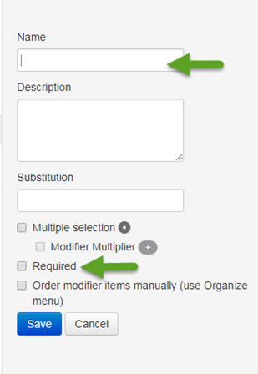
Now you can add the types of sauce that they can choose from. You’ll want to make sure to click on Choose Your Sauce, and then click on Choose Your Sauce Modifier Items.
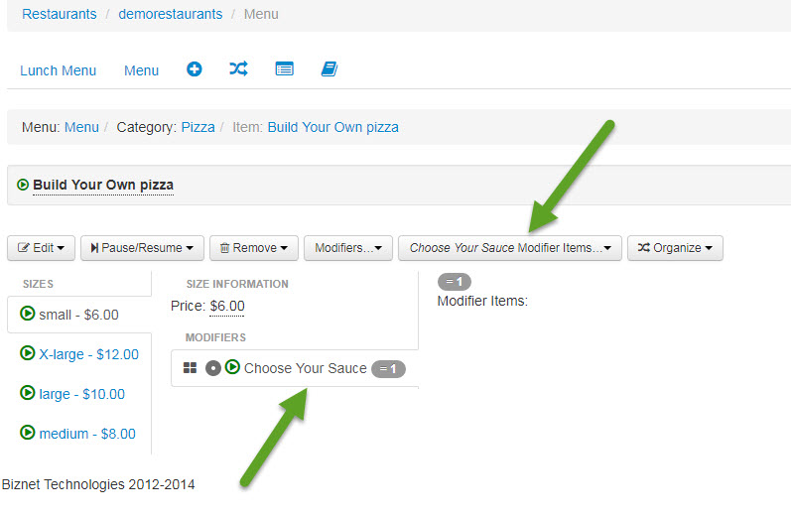
So once you click on Choose Your Sauce Modifier Items you’ll notice on the right hand column the following option:
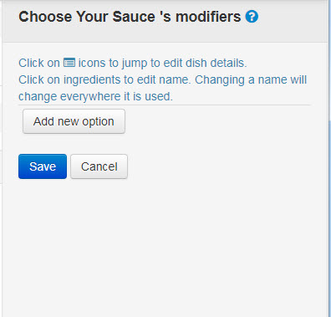
You’ll want to click on Add new option, which will create a box for to name the modifier and add a price to it is there is a price:
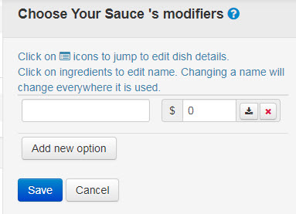

So let’s add three choices for our customers, Red Sauce, White Sauce and Vodka Sauce. But you’ll see that for the Vodka Sauce, there is an additional charge of $3.00.

So what happens when someone calls and says, I need to pause one of my items because they’re sold out.
So you’ll want to go into the client that’s calling, in this case it will be the demorestaurants customer.
So if they would call to say, we’ve run out of Grilled Cheese and won’t have any until tomorrow. There are two different routes that you can take.
You’ll want to find the item and click on it:
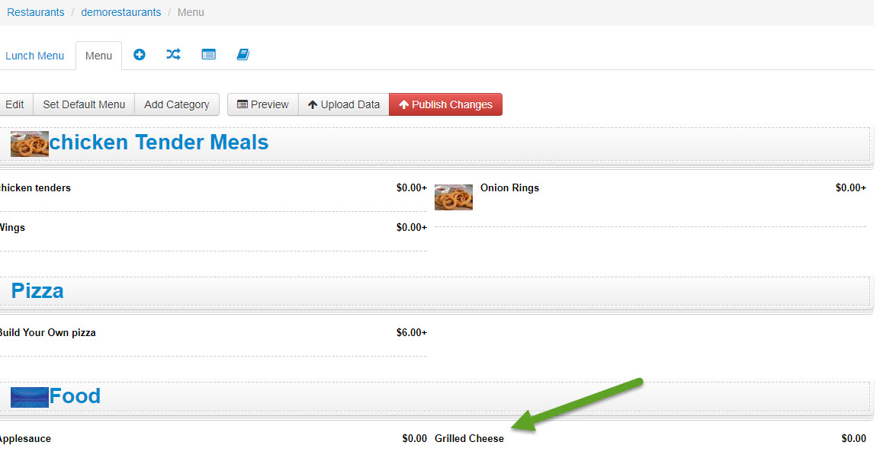
Once you click on it you’ll be taken to the screen you’ve seen before with the name of the item, the modifiers etc.
From that screen you’ll want to go to the button that says Pause / Resume.
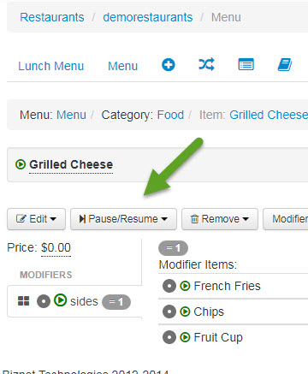
Once you click on it you’ll see the following menu pop up:
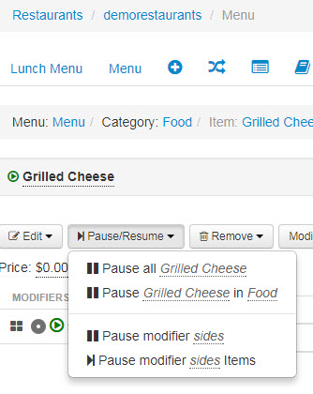
So you see Pause all Grilled cheese, Pause Grilled Cheese in Food, Pause modifier sides and Pause modifier sides items
Pause all Grilled cheese- This will pause all items on all of their menus called Grilled Cheese. So if they have it on their lunch menu and their dinner menu it will pause it everywhere.
Pause Grilled Cheese in Food- This will pause Grilled Cheese just in the Category Food.
Pause modifier sides- This will pause the modifier Sides in Grilled Cheese in the Category food.
Pause modifier sides items- This will allow you to pause certain side items.

So seeing as Grilled Cheese is only listed in one place on their menu we’re going to select Pause Grilled Cheese in Food.

Once we click on that you’ll see the following show up on the right side column:
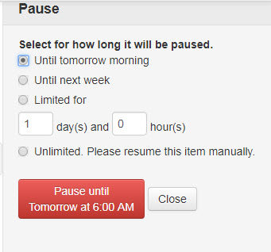
There are different options for you here in this menu. If they’re going to have it back on the menu tomorrow then you could select until tomorrow morning. You’ll see the text in the red box will tell you how long the item will be paused to, paused until tomorrow at 6:00am.
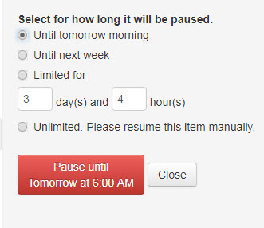

If I select until next week the text in the red box changes to Pause until Monday at 6:00am
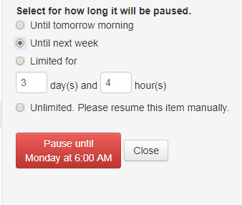
If I select limited for, I can then choose how long it’s going to be paused for. So say there is a massive cheese outage that’s going to last for 3 days 4 hours. You would select limited for and then input 3 days and 4 hours and you’ll see the text in the red box change to Pause until Saturday at 8:15pm.
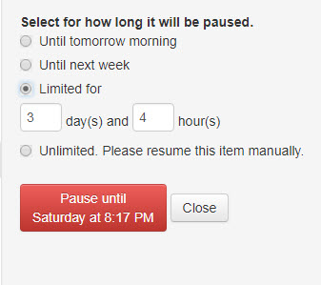

Then there is Unlimited. If you choose unlimited the text in the red box will change to Pause until manually resumed.
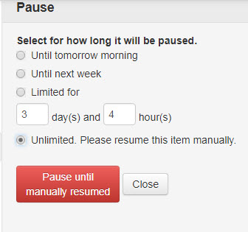

All of these will un-pause the item automatically EXEPCT for unlimited. This is the only one that you’ll have to go back into the system and physically resume the item.
So for an example, let’s click on unlimited so you can see how it will show on their menu.
You can now see that Grilled cheese is grayed out, showing that it’s currently paused in the menu. Customers will not see this item on the active menu when they go to try and order.
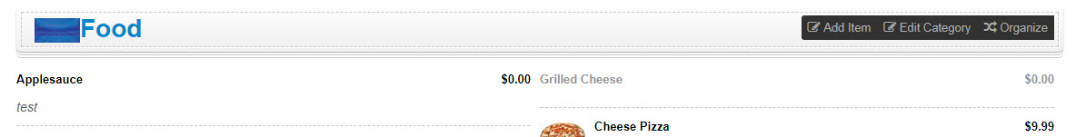

To make the item active again, you would just go back and click on the item that is currently paused, again click on paused/ resume and you’ll now see instead of pause grilled cheese in food it says Resume grilled cheese in food.
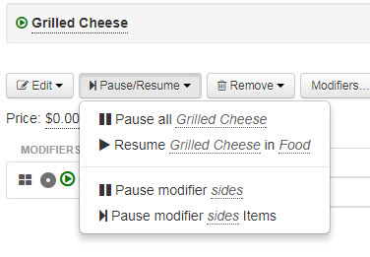
You would just click on resume Grilled Cheese in Food and it will be active again.

Refunds and or cancelations on orders.
There are specific steps we need to take If a business ever calls and or e-mails you and lets you know that they need to do a refund or they need to cancel and order that’s been placed.

We here at Clipper cannot cancel and or refund orders. All of these requests need to be sent to Zuppler.
The easy way to handle there is to make sure that we have the ID # of the order. Every order placed with TLS OO has an order ID # that’s associated with it which is usually alphanumeric (letters and #’s). We would always like to get that order # as it’s the quickest way to make sure the refund / cancel order is taken care of. If they do not have order # that’s ok, we would then just need to know the name of the customer, their address (if one is given) the restaurant name of course, the payment type and when they placed it.

All of this information is helpful in getting the order canceled / refunded as quickly as possible.
The only time that you’ll have to worry about these is if the client paid with a CC. If they paid with cash, the restaurant would just do the refund there at the store.

Here is an example of the information we’d need:
